CPP NOTES
- Hello World
Linking:-
Multiple statements (single line of code) make a source code (code understood by humans) which is accessed by compiler to create object files (code understood by computer) that are linked together through a linker to create an EXECUTEABLE FILE
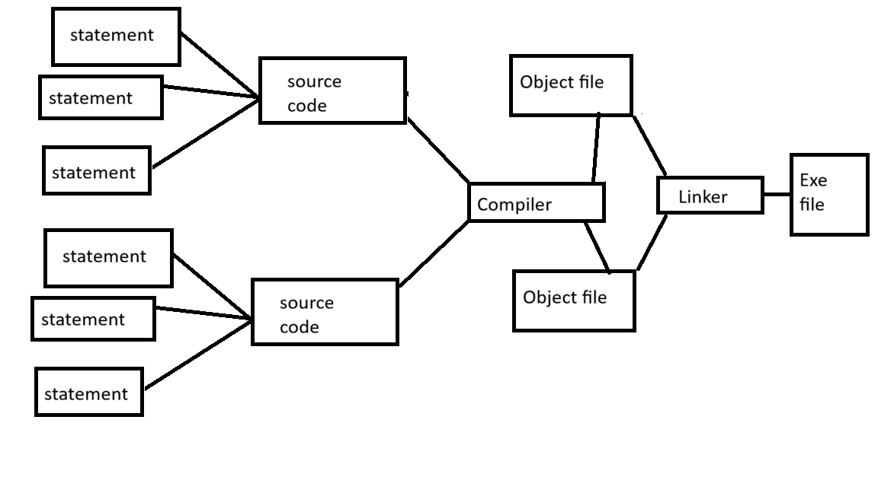
Library is simply some code written by others that we access using declarations (include namespace std). They are found in imported modules.
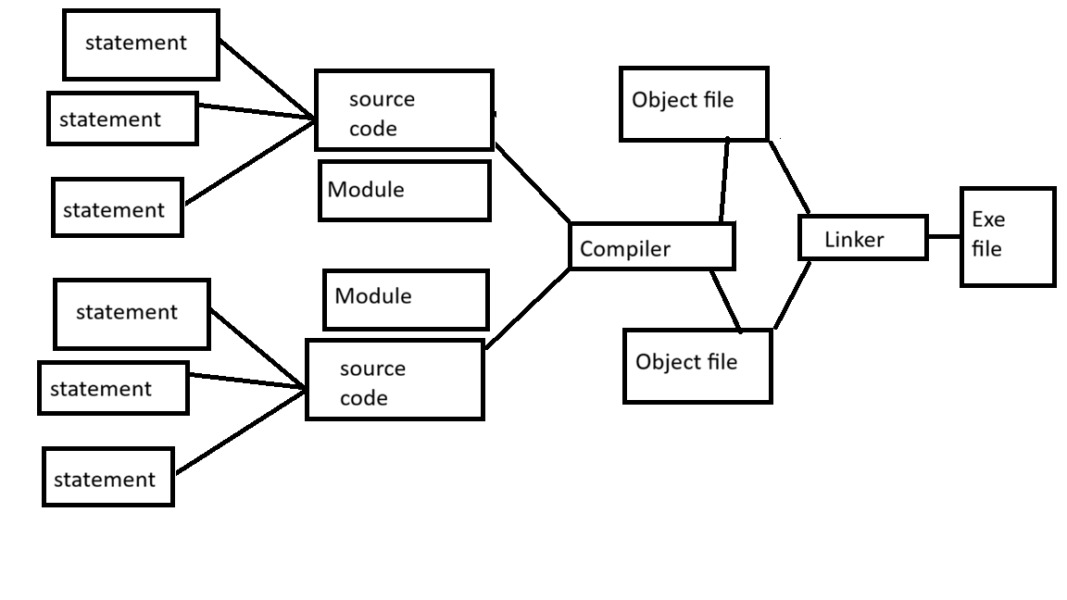
Compile time errors (during compilation)
Link time errors (during linking)
Run time errors (during execution)
- Objects, Types and Values
Object = memory space specified with what type of data can be stored in it
A named object is called a variable.
Names are necessary to access the object
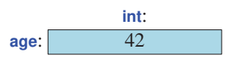
Definition = defines a variable; for example
int age =12;
String name;
Initializer = name followed by = ; for example
Int age = 12
String name = Abdullah
Operators:-
For strings (a and b), checks which asci value is greater or smaller (<,>) character by character
For example:
String a = cat
String b = car
Do (a<b)
C=C (Same ASCI VAL)
A=A (Same ASCI VAL)
T != R (diff ASCI VAL)

Composite assignment operators:-
Int i=9;
Cout<<++i; (i=10) //first increment then assign
Cout<<i++; (i=10) //first print then assign
Cout<<i; (i=11)
Names:-
Names starting with _ (such as _foo) are reserved for system entities
Names with all caps (FOO) reserved for macros
Types and Objects:-
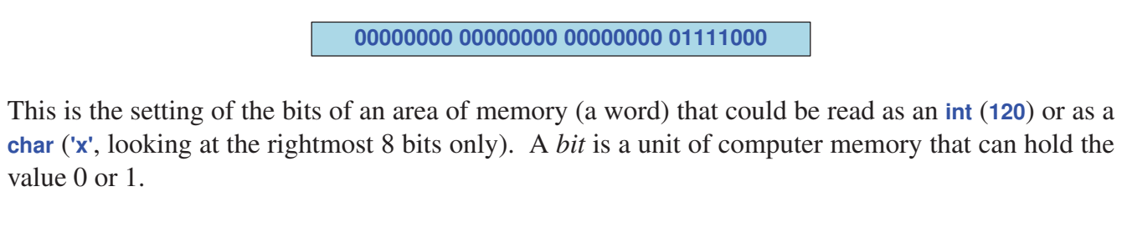
Conversions:-
Char c = ‘x’; // x has ASCII val 120
Int i1 = c; // x converts to 120
Int i2 = c+1000 // 120+1000 = 1120
Double d = i2 +7.3 // 1120+7.3 = 1127.3

Going from larger to smaller type (narrowing conversions) causes data loss. Example: 12043(int)->x(char) causes 43 to be lost because char is one byte and int is 4 bytes

IMP:
To avoid narrowing bugs;
Brace initialization is used. Example
Int x = 7.8 // becomes 7 (problem)
Int x {7.8} OR int x = {7.8} // compile time error (fix)

Direct VS Copy initialization; (both allow narrowing)
Direct = int x3 (3) // calls constructor directly (more efficient for classes)

Copy = int x3 = 3 //may involve extra copy (less efficient)
Type Deduction - Auto: -
Instead of doing
Int x = 7;
Int d = 7.4;
Use auto to let the compiler deduce the datatype by itself for obv initializers (7,7.4)
Auto x =7
Auto d =7.5

